Experiment 11:
integrate Kubernetes and docker
Kubernetes is an open-source tool that allows you to run and manage your container-based workloads. Kubernetes K8s was Developed by google and was later donated to the Cloud Native Computing Foundation.
Kubernetes helps you manage hundreds and thousands of containerized applications in different deployable environments be it physical machines, virtual machines, cloud or even hybrid environments!
In simple words, it’s a container orchestrator that helps makes sure that each container is where it’s supposed to be and that the container can work together. To put it another way, it is pretty similar to a conductor that manages everything in an orchestra. Since there are a lot of moving points in the scalable application, the same way how a conductor is responsible for making the song sound good similarly K8s makes sure the services smoothly the way an app developer wants.

Getting Started with Deploying Docker Containers to Kubernetes
Once you understand what containers and Kubernetes are, the next step is to learn how the two work together. This guide provides an example of containerizing a simple application using Docker and deploying it on Kubernetes.

What is Docker?
Docker is an open source container platform that uses OS-level virtualization to package your software in units called containers. Containers are isolated from each other and are designed to be easily portable. You can build, run and distribute applications in Docker containers to run on Linux, Windows, Macs and almost anywhere else–both on-premises and in the cloud. The Docker environment also includes a container runtime as well as build and image management.

Docker Containers
A Docker container image is a lightweight, standalone, executable software package that includes everything needed to run an application: code, runtime, system tools, system libraries and settings. Docker provides a standard format for packaging and porting software, much like ISO containers define a standard for shipping freight. A runtime instance of a Docker image consists of three parts:
- The Docker image
- The environment in which the image is executed
- A set of instructions for running the image

How to Run a Docker Container in Kubernetes
A containerized application image along with a set of declarative instructions can be passed to Kubernetes to deploy an application. The containerized app instance running on the Kubernetes node derives the container runtime from the Kubernetes node along with compute, network, and storage resources, if needed.
Here’s what it takes to move a Docker container to a Kubernetes cluster.
- Create a container image from a Dockerfile
- Build a corresponding YAML file to define how Kubernetes deploys the app

Dockerfile to Create a Hello World Container Image
A manifest, called a Dockerfile, describes how the image and its parts are to run in a container deployed on a host. To make the relationship between the Dockerfile and the image concrete, here’s an example of a Dockerfile that creates a “Hello World” app from scratch:
FROM scratch
COPY hello /
CMD ["/hello"]

When you give this Dockerfile to a local instance of Docker by using the docker build command, it creates a container image with the “Hello World” app installed in it.

Creating a Kubernetes Deployment for Hello World
Next you need to define a deployment manifest, commonly done with a YAML or JSON file, to tell Kubernetes how to run “Hello World” based on the container image:
# Hello World Deployment YAML
apiVersion: apps/v1
kind: Deployment
metadata:
name: helloworld
spec:
selector:
matchLabels:
app: helloworld
template:
metadata:
labels:
app: helloworld
spec:
containers:
- name: helloworld
image: boskey/helloworld
resources:
limits:
memory: "128Mi"
cpu: "500m"
To deploy the application on a Kubernetes cluster, you can submit a YAML file using a kubectl command similar to the following.
kubectl apply -f https://yourdomain.ext/application/helloworld.yaml --record
Once that’s done, the hello world container is deployed in a Kubernetes pod.

Creating a Kubernetes Service
The container is now deployed to Kubernetes but there is no way to communicate with it, the next step is to turn the deployment into a Service by establishing communication.
In Kubernetes, a Service is an abstraction which defines a logical set of pods and a policy by which to access them. This guide demonstrates a basic method of providing services to pods.

Application Labels and Services

Labels
A very interesting aspect of Kubernetes is the way Kubernetes combines the use of Labels and Services to create tremendous possibilities.
At the heart of Kubernetes is a pod. A pod contains running instances of one or more containers. When a pod is deployed in Kubernetes, apart from other specifications, the pod can be assigned labels. Ideally a pod is given a label identifying which part of the overall application the pod belongs to. For example, if the pod being deployed is for the application ”frontend” and within “frontend” the pod is running code for login, upon deployment it can be labeled [app=frontend,label=login]. Other pods deployed as part of this tier can be given the same label.

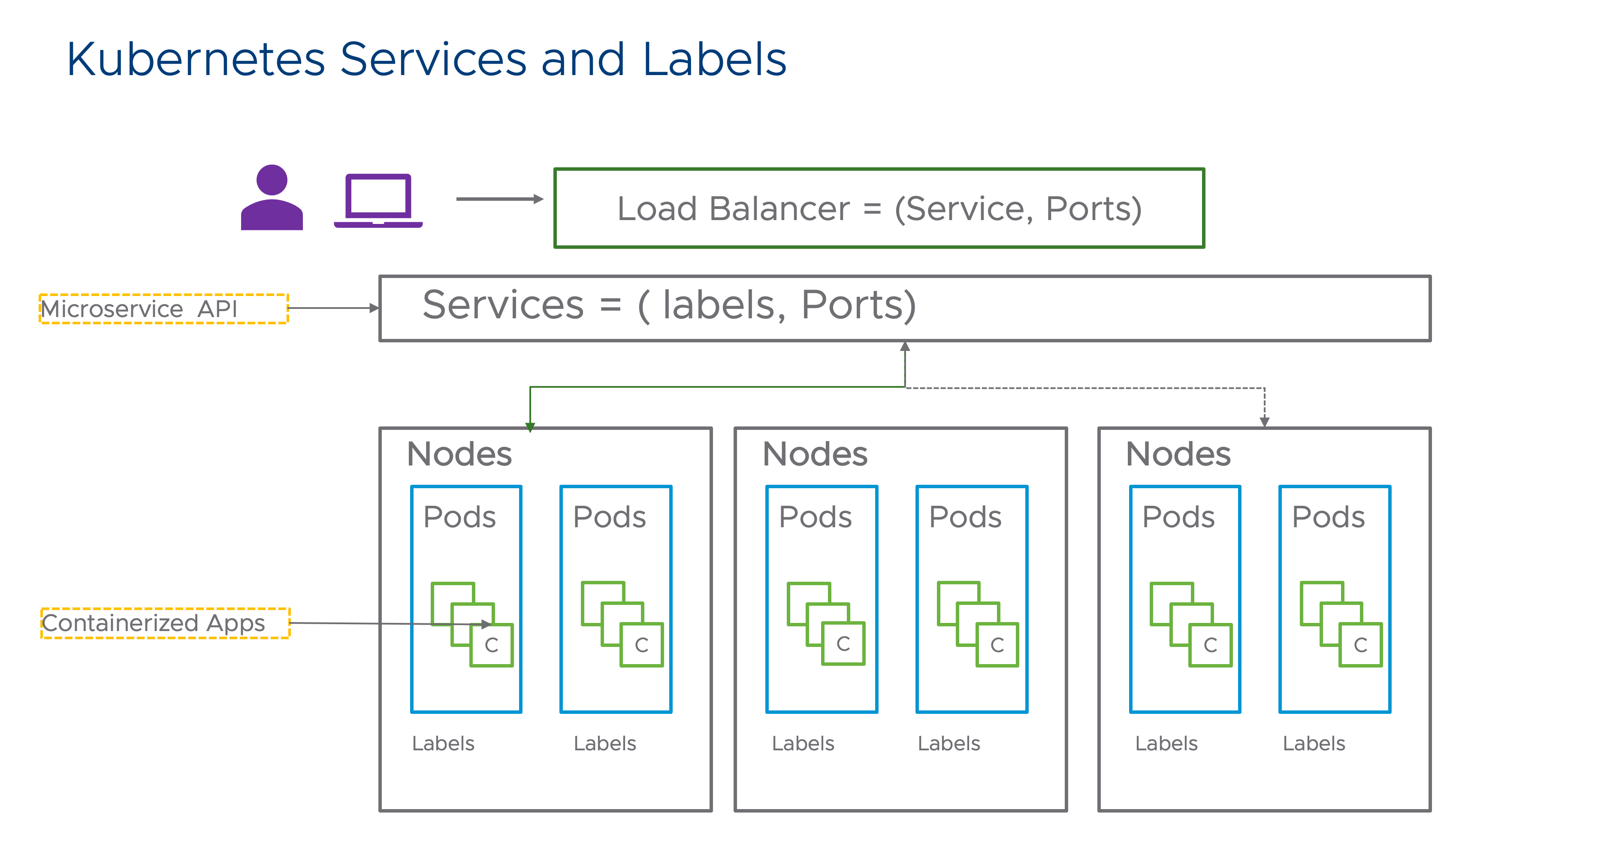

Services
Services enable Kubernetes to route traffic to pods. Pods in Kubernetes are deployed on an overlay network. Pods across Kubernetes nodes cannot access each other nor can any external/ingress traffic access pods unless a Service type resource is defined. A service is routed to the correct app using a label. So when a service gets created with label login,the service will send traffic to pods that contain the login app based on the label match. Services are needed for both East-West communication, when two pods from different apps need to talk to each other, and for North-South communication, when external traffic ( outside of the Kubernetes cluster) needs to talk to a pod. Kubernetes has different service types to address both scenarios. Some common services are listed below:

Service Type | Depends on | What it Does | Traffic Type Handled
Cluster IP | Cluster Network | Uses the Cluster Network to MAP pod IP/port | Internal to the Cluster
Node Port | Cluster IP | Uses a port on Kubernetes Node + creates a mapping of Node port to the Cluster IP | External
Load Balancer | Cluster IP/Node Port | Creates an External Load Balancer that maps to either a Cluster IP/Node Port | External
The services resource constructs in Kubernetes may be a microservice or other HTTP services.

Hello World service definition
A corresponding service definition for the earlier “Hello World” deployment manifest is shown below. Notice line 5 onward. With the selector as "app: hello world" the service will forward traffic coming to port 80 on the cluster network to pods that match this label.
apiVersion: v1
kind: Service
metadata:
name: helloworld
spec:
selector:
app: helloworld
ports:
- port: 80
targetPort: 80

The Power of Services
Because of label matching, there is no need to understand the IP addressing of pods to load balance traffic. As a result:
- Load balancing traffic across multiple pods is simplified.
- Updating an app (in a pod) can be as simple as:
  - Deploying apps with new version labels ( e.g, v.1.5)
  - Waiting for all deployments to complete
  - Updating the corresponding Service’s labels to match the new pods.
- Traffic shaping: Using Ingress, incoming app traffic can be split between multiple labels, making it simple to do things like A/B testing.

experiment 12:
Automate the process of running containerized application developed in above exercise using Kubernetes.

Step 1: Create a deployment manifest Create a YAML file (e.g., deployment.yaml) and define the deployment configuration. Replace <container-registry>/<image-name>:<tag> with the actual path to your Docker image in the container registry.

apiVersion: apps/v1
kind: Deployment
metadata:
name: my-app-deployment
spec:
replicas: 3
selector:
matchLabels:
app: my-app
template:
metadata:
labels:
app: my-app
spec:
containers:
- name: my-app-container
image: <container-registry>/<image-name>:<tag>
ports:
- containerPort: 3000

Step 2: Create a service manifest Create another YAML file (e.g., service.yaml) and define the service configuration.

apiVersion: v1
kind: Service
metadata:
name: my-app-service
spec:
selector:
app: my-app
ports:
- protocol: TCP
port: 80
targetPort: 3000
type: LoadBalancer

Step 3: Apply the manifests using kubectl To automate the process, you can use the kubectl command-line tool to apply the deployment and service manifests to your Kubernetes cluster.

kubectl apply -f deployment.yaml
kubectl apply -f service.yaml

The above commands will create the deployment and service in your Kubernetes cluster, and your application will be up and running with the specified number of replicas.
You can create a shell script to automate these steps further. For example, create a file named deploy.sh and add the following content:

#!/bin/bash

kubectl apply -f deployment.yaml
kubectl apply -f service.yaml

Make the script executable:

chmod +x deploy.sh

Now, you can simply run ./deploy.sh in your terminal to deploy your application to the Kubernetes cluster.
By automating the process, you can easily redeploy your application whenever there are updates or changes to your Docker image or Kubernetes manifests, without the need for manual intervention.

